## *Bikeability* Cycle Training.

Dear Parent/Carer

Our school is to receive **Free** *Bikeability* Cycle Training!

*Bikeability* is the UK’s cycling proficiency for the 21st century, designed to give children the ability and confidence to ride their bikes on today's roads.

Your child’s new skills will boost confidence and help him/her to be a safer road user. They’ll not only become better cyclists but also safer pedestrians, and when older, better drivers. Learning the rules of the road when young is a real boost to confidence and a very positive experience of true travel independence. So, whether your child cycles regularly or not, the course will prove beneficial.

**Course Requirements:**

Children should already be able to start, stop and ride a short distance independently (around 20 metres minimum). It is essential that all bicycles be in good working order and that they are a suitable size for the rider.

**The enclosed Bike Safety Checklist will help you check your child's bike.**

**Pupils also need to be equipped with a cycle helmet and suitable clothing appropriate to the seasonal weather.**

**Some Information about the Programme:**

Training will be carried out by ‘Learncycling’, a National Training Organisation who have been appointed by Shropshire Council to deliver this programme. All Instructors are fully trained and accredited and have undergone the necessary DBS checks.

A significant amount of training will take place outside of the school premises on roads around the vicinity of the school, for which the organisers provide each pupil with a High Visibility vest. The children are given training appropriate to their ability and will be awarded a certificate and badge at the end of the course. Any relevant feedback on areas to improve on will be written on the reverse of the certificate.

*Bikeability* offers something really positive for your child. Although the elements of the course are serious in terms of using roads more safely, the dynamics of the course involve positive messages about cycling on the road and delivered in a challenging and fun way.

If there are any other aspects of the programme which you’d like to clarify, please do not hesitate to contact the school.

I do hope you will register your child for this training**,** which is on **Tuesday 25 and Wednesday 26 September,** and look forward to receiving your completed acceptance slip by the end of this term so that we can confirm the number of children participating**.**

*Signature*

**Bike** Safety **Checklist**:

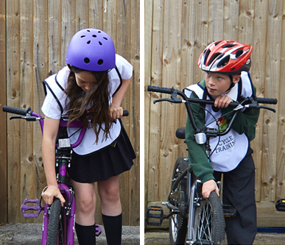

Before the course, please carry out a Bicycle A, B, C check to ensure bikes are safe to ride.

A – **Air** – Please check that tyres are inflated and are in good condition.

B – **Brakes** – Bikes that are ridden on the road need to have two working brakes by law. Please make sure both brakes work and can be used by your child.

C – **Chain** – Chains should not be rusty and should rotate freely. Hold the pedal and turn it backwards.

* Please also ensure that your child’s bike is the correct height for them. When sitting on the saddle, they should be able to touch the floor with their toes or the front part of their foot. If their knees are bent, they may need their saddle raising.

…………………………………………………………………………………………………………………..

