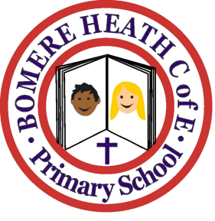

Achievement Awards for week ending ……12.10.18………………….

Class | Independent Worker | Amazing  Effort | Star of  the Week
Pimhill | Pippa | Martha | Cortina
Haughmond | Ciaran | Poppi | Dylan
Grinshill | Zara | Evan | Max
Stiperstones | Seth | Millie | Libby
Wrekin | Daisy | Aaron | Josh

