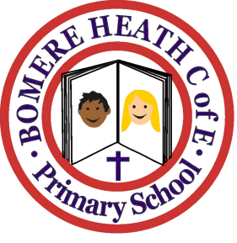

Achievement Awards for week ending 19 October 2018

Class | Independent Worker | Amazing  Effort | Star of  the Week
Pimhill | Hunter | Archie T | Bethany
Haughmond | Annabelle | Ruby | Archie W
Grinshill | Maisy | Henry | Archie F
Stiperstones | Shelby | Jack | Lily P
Wrekin | Beth | Owen | Eddie

