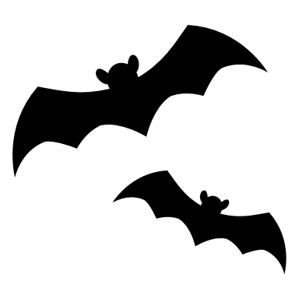
BOMERE HEATH PRIMARY SCHOOL
HALLOWEEN DISCO
THURSDAY 25th OCTOBER 2018
KS1: 5.30pm to 6.30pm | Prize for the best costume at each disco
KS2: 6.45pm to 7.45pm | £2 per child – including refreshments  Please Pay on the Door
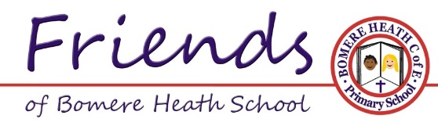
BOMERE HEATH PRIMARY SCHOOL
HALLOWEEN DISCO
THURSDAY 25th OCTOBER 2018
KS1: 5.30pm to 6.30pm | Prize for the best costume at each disco
KS2: 6.45pm to 7.45pm | £2 per child – including refreshments  Please Pay on the Door
BOMERE HEATH PRIMARY SCHOOL
HALLOWEEN DISCO
THURSDAY 25th OCTOBER 2018
KS1: 5.30pm to 6.30pm | Prize for the best costume at each disco
KS2: 6.45pm to 7.45pm | £2 per child – including refreshments  Please Pay on the Door
BOMERE HEATH PRIMARY SCHOOL
HALLOWEEN DISCO
THURSDAY 25th OCTOBER 2018
KS1: 5.30pm to 6.30pm | Prize for the best costume at each disco
KS2: 6.45pm to 7.45pm | £2 per child – including refreshments  Please Pay on the Door

