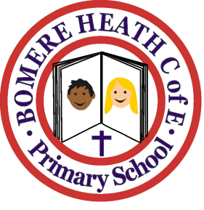

Achievement Awards for week ending ……5.10.18………………….

Class | Independent Worker | Amazing  Effort | Star of  the Week
Pimhill | Serena | Ollie-Blue | Freya
Haughmond | Anya | Kieran P | Jess
Grinshill | Aimee | Mack | Imogen
Stiperstones | Lilly M | Mason | Isobel H
Wrekin | Eddie | Josh | Milo

