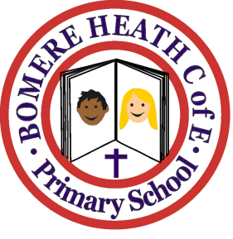

Achievement Awards for week ending 9 November 2018

Class | Independent Worker | Amazing  Effort | Star of  the Week
Pimhill | Not awarded | Amellia | Patrick and Dominic
Haughmond | May | Sorrell | Annabelle
Grinshill | Olivia | Max | Gracie
Stiperstones | Seth | Ellie | Whole Class
Wrekin | Leo | Rosie | Aaron

