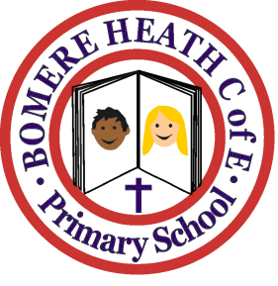

Achievement Awards for week ending 16 November 2018

Class | Independent Worker | Amazing  Effort | Star of  the Week
Pimhill | Indi | Harvey | Otto
Haughmond | Ruby | Marley | Paige
Grinshill | Henry | Brennie | Archie
Stiperstones | Millie | Whole Class | Joe
Wrekin | Ella | Maddy | Charlie J

Special achievement for choir: Aaron

