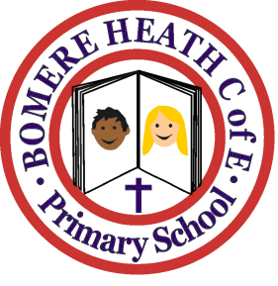

Achievement Awards for week ending November 23rd 2018

Class | Independent Worker | Amazing  Effort | Star of  the Week
Pimhill | Gabby | Oliver | Jessica
Haughmond | Dylan | Evan | Ciaran
Grinshill | Olivia | Maisy | Chloe
Stiperstones | Eti | Tom | Will
Wrekin | Ella | Jamie | Owen

