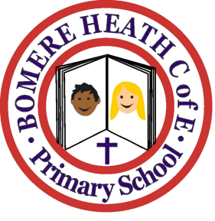

Achievement Awards for week ending 14 December 2018

Class | Independent Worker | Amazing  Effort | Star of  the Week
Pimhill | Maddison | Bethany A | Odin
Haughmond | Molly | Jess | Evan
Grinshill | Lewis | Evan | Zachary
Stiperstones | Isobel H | Eti | Millie
Wrekin | Bethany | Joe | Sam

