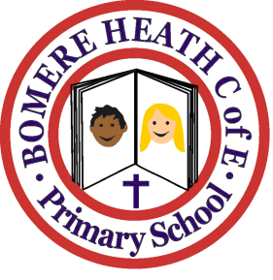

Achievement Awards for week ending 7 December 2018

Class | Independent Worker | Amazing  Effort | Star of  the Week
Pimhill | Harrison | Obosa | Archie
Haughmond | Dylan | Paige | Ruby
Grinshill | Jake | Ewan | Ben
Stiperstones | Ava | Oscar | Malcolm
Wrekin | Sam | Beth | Daisy

