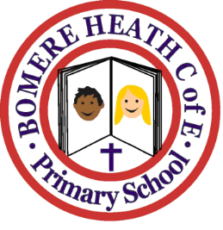

Dates for Your Diary
Spring Term 2019

Friday 1 February | Cross Country Level 2 competition for selected pupils, at Oswestry School
Monday 11 – Wednesday 13 February | Year 6 pupils to Arthog residential visit
Friday 15 February | Year 5 pupils Languages Day at Corbet School
Monday 18 – Friday 22 February | Half-Term Holiday, school closed
Friday 1 March | Grinshill class trip to Chester Zoo – more information to follow
Friday 1 March | Year 5 Maths Challenge for selected pupils at Wrekin College
Thursday 7 March | World Book Day – Pupils invited to dress up as a book character. World Book Day £1 book tokens to be distributed
Thursday 14 March - evening | Family Bingo evening organised by Friends of Bomere Heath School – more details and date to be confirmed
Wednesday 20 March | Stiperstones class trip to Shrewsbury Museum & Art Gallery –more information will follow
Tuesday 26 March | Pimhill class trip to Blists Hill Victorian Museum
Sunday 31 March | Mothering Sunday Service at Leaton Church 10.30am All families invited, children in Pimhill and Haughmond Classes will be participating in the Service if possible.
Thursday 4 April | ‘Key Strings’ Musical ensemble taking workshops for KS1 and KS2 during morning
Thursday 4 April | Parents Evening – formal appointments to be made, between 3.30 -6.30pm. Appointment letters will go out nearer the time.
Friday 12 April  Monday 29 April | Last Day of Spring Term  First Day of Summer Term

