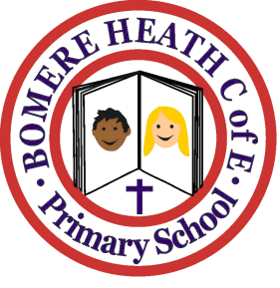

Achievement Awards for week ending 11 January 2019

Class | Writer of the Week | Star of  the Week
Pimhill |  | Annabelle
Haughmond |  | Marley
Grinshill |  | Brennie
Stiperstones |  | Lily
Wrekin |  | Josh

