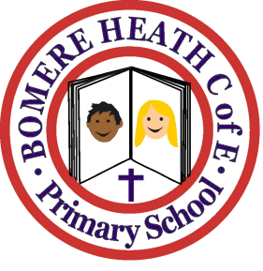

Achievement Awards for week ending 18 January 2019

Class | Writer of the Week | Star of  the Week
Pimhill | Obosa | Serena
Haughmond | May | Paige
Grinshill | Gurkirat | Cadence
Stiperstones | Will | Jasmyn
Wrekin | Florence | James

