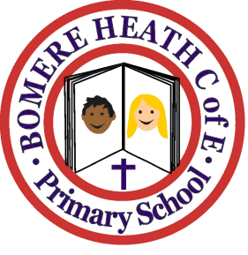

Achievement Awards for week ending 25 January 2019

Class | Writer of the Week | Star of  the Week
Pimhill | Harrison | Beth W
Haughmond | Molly | Ridley
Grinshill | Imogen | Henry N
Stiperstones | Mason | Lilly M
Wrekin | Beth T | Charlie G

