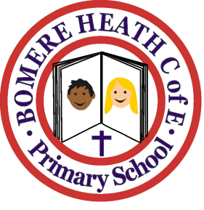

Achievement Awards for week ending 15th February 2019

Class | Writer of the Week | Star of  the Week
Pimhill

Haughmond

Grinshill

Stiperstones

Wrekin | Rosie | Charlie J

Star of the Half-Term
Pimhill: Martha
Haughmond: Jessica
Grinshill: Imogen
Stiperstones: Ava
Wrekin: All Year 6 pupils, for being a pleasure to take to Arthog and helping each other overcome their challenges

