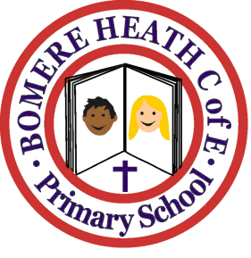

Achievement Awards for week ending 1st February 2019

Class | Writer of the Week | Star of  the Week
Pimhill | Otto | Archie
Haughmond | Lara | Crystal
Grinshill | Jack | Olivia
Stiperstones | Ellie | Millie
Wrekin | Rosie | Patrick

