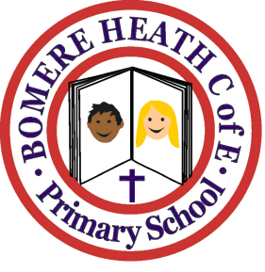

Achievement Awards for week ending 8th February 2019

Class | Writer of the Week | Star of  the Week
Pimhill | Indi | Harvey
Haughmond | Jess | Anya
Grinshill | Gracie | Jamie
Stiperstones | Libby | Malcolm
Wrekin | Aaron | Maddy

