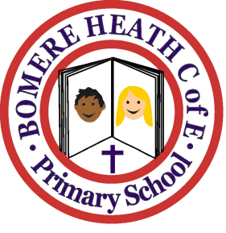

Achievement Awards for week ending 15 March 2019

Class | Writer of the Week | Star of  the Week
Pimhill | Serena | Maddie
Haughmond | Dylan | Kieran
Grinshill | Gurkirat | Maisy
Stiperstones | Millie | Ellie
Wrekin | Florence | Cameron

