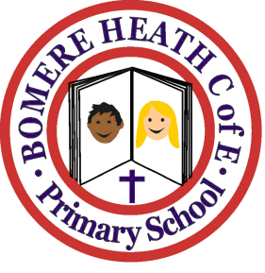

Achievement Awards for week ending 22 March 2019

Class | Writer of the Week | Star of  the Week
Pimhill | Oliver | Ollie-Blue
Haughmond | Marley | Paige
Grinshill | Henry | Jamie
Stiperstones | Shelby | All Stiperstones Class
Wrekin | Milo | Fin

