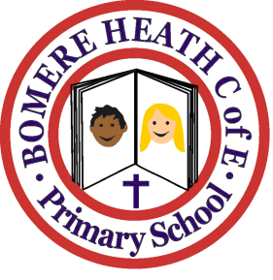

Achievement Awards for week ending 8 March 2019

Class | Writer of the Week | Star of  the Week
Pimhill | Freya | Gabby
Haughmond | Xavier | Crystal
Grinshill | Zachary | Maisy
Stiperstones | Isobel H | Scarlett
Wrekin | Lee | Rosie

