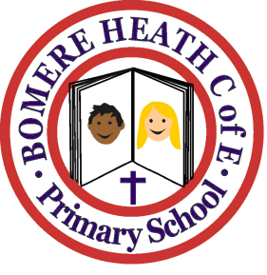

Achievement Awards for week ending 12 April 2019

Class | Spring Term Reading Champion | Star of the Half-Term
Pimhill | Freya | Clara
Haughmond | Jessica | Ruby
Grinshill | Imogen | Max
Stiperstones | George | Isobel H
Wrekin | Owen | Rosie

