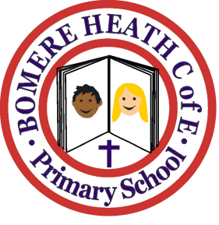

Achievement Awards for week ending 5 April 2019

Class | Writer of the Week | Star of  the Week
Pimhill | Pippa | Bradley
Haughmond | Francine | Dylan
Grinshill | Archie | Saffron
Stiperstones | Will | Ava
Wrekin | Sam | Ella

