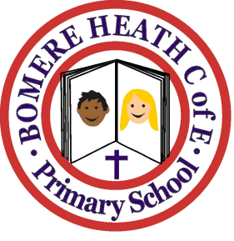

Achievement Awards for week ending 29 March 2019

Class | Writer of the Week | Star of  the Week
Pimhill | Ammelia | All Pimhill Class
Haughmond | Ridley | Sorrel
Grinshill | Zara | Evie
Stiperstones | Mason | Seth
Wrekin | Joe | Clemmy

