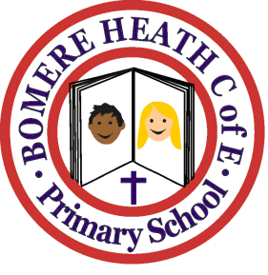

Achievement Awards for week ending 10 May 2019

Class | Writer of the Week | Star of  the Week
Pimhill | Pippa | Amellia
Haughmond | Francine | Ciaran H
Grinshill | Mia | Jake
Stiperstones | Ronnie | George
Wrekin | Maddy | Josh

