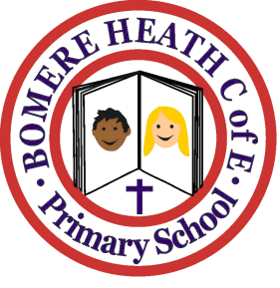

Achievement Awards for week ending 17 May 2019

Class | Writer of the Week | Star of  the Week
Pimhill | Sam | Cortina
Haughmond | Crystal | Molly
Grinshill | Imogen | Saffron
Stiperstones | Lily P | Ellie
Wrekin | Levi | James

