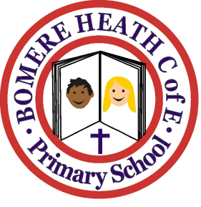

Achievement Awards for week ending 3rd May 2019

Class | Writer of the Week | Star of  the Week
Pimhill | Cortina | Brooke
Haughmond | Annabelle | Dylan
Grinshill | Imogen | Kaynen
Stiperstones | Isobelle | Seth
Wrekin | Daisy | Charlotte

