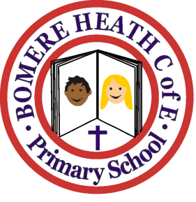

Achievement Awards for week ending 7 June 2019

Class | Writer of the Week | Star of  the Week
Pimhill | Obosa | Odin
Haughmond | Anya | Scarlett
Grinshill | Ben | Evan
Stiperstones | Millie | Mason

