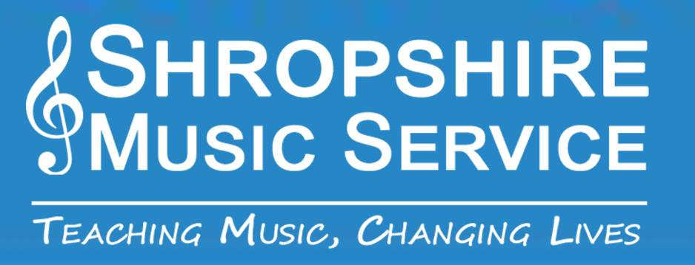

Supplementary Terms and conditions for Online Instrumental lessons
By supplying Shropshire Music Service with your email address and requesting lessons for your child, you are agreeing to the following additional terms and conditions:
- Online lessons are a temporary solution to the problems caused by the Covid-19 pandemic. Once Schools reopen and SMS is able to visit, lessons will return to normal
- Shropshire Music Service will pass the parent email to the relevant teacher who will then contact the parent to arrange lesson times.
- Parents must be present when online lessons are being delivered. If it is not clear that a parent or carer is nearby, the lesson will not continue.
- A suitable internet connection with audio and video hardware needs to be available. We are not able to provide any equipment or technical support
- The lesson will take place using only the ‘Zoom’ platform. It is free and readily available by searching the word zoom.
- The lesson must take place in a communal area of the house.
- Pupils must have their instruments and music ready.
- Where possible they should have a music stand and a suitable chair if they usually use one
- Pupils must be fully dressed in appropriate clothes.
- Zoom must be used for the lesson only. Any other enquiries should be directed to Shropshire music service at the following address admin@shropshiremusicservice.org.uk
- Lessons will, where possible, be delivered by the pupil’s regular teacher. However, where this is not possible, an alternative teacher may be asked to deliver the lesson. This teacher will display his or her ID badge clearly.

