Getting ready for September
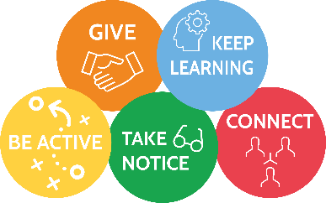

Try a new hobby or game | Learn to prepare something to eat | Get in touch with at least 3 friends | Play outside with a friend | Look at your school website and find out what is happening
Set up a treasure hunt with clues for a friend | Practise some breathing exercises that your teacher has shared | Try to go to bed as if it is school time | Start getting up as if it is school time | Make a list of all the questions you have about school
Visit a neighbour you have met during lockdown when it is safe | Make a list of all the good things that have happened during lockdown | Write or draw a picture to represent lockdown | Make a happiness box to bring into school | Complete the mindfulness colouring you have been sent
Go for a walk every day | Lie and your back and look at the clouds, see if you can spot some animal shapes | Build a den inside and outside | Complete a random act of kindness for someone | Climb a tree with an adult nearby
Laugh until your tummy hurts | Splash in the puddles | Make a daisy chain | Make a sculpture out of anything you can find | Put together a new dance to perform to someone you love
Write a song or poem about what you have missed most | Plant some seeds and look after them, then bring your plant to school | Camp outdoors and tell each other stories | Go on a picnic in the wild | Make a bug hotel for the little beasts in your garden
Make a piece of art from sticks | Play Pooh sticks | Roll down a big hill | Fly a kite | Climb a big hill
Take photos of special people and places | Sing as loud as you can | Bake a cake | Write a wish list for next school year | Read your favourite book

