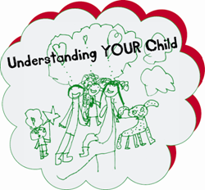

If you would like to find out about other services the Parenting Team offers please email [Parenting.team@shropshire.gov.uk](mailto:Parenting.team@shropshire.gov.uk)

or call us on 01743 250950

***PARENTING HELP AND SUPPORT LINE***

available

**Monday to Thursday from 9.30am to 4.30pm**

and

**Friday 9.30am to 3.30pm**

You can contact the Parenting Help and Support Line by calling

***01743 250950***

Parenthood can be extremely rewarding and enjoyable. It can also be demanding, frustrating and exhausting. The Parenting Team is here to support parents and carers to raise healthy, well-rounded children in a loving and stable environment.

Do you have any questions around child development and parenting?

Why not call our Parenting Help and Support Line where one of our trained

Parenting Practitioners will be ready to listen.

(Please note the Parenting Help and Support Line will not operate Bank Holidays and between Christmas & New Year)

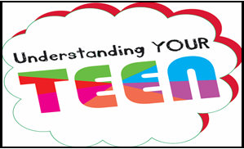

If you have concerns about a child’s safety or well-being, please call

**First Point of Contact 0345 678 9021**