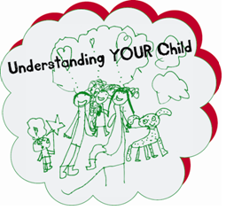

* *Would you like to know more about your child’s development?*
* *Do you need support to understand your child’s behaviour?*
* *Would you like a chance to meet & chat with other parents and carers?*

***UNDERSTANDING YOUR CHILD GROUPS***

The groups are delivered virtually via MS Teams or face to face at a venue in Shropshire

All our groups run for 10 weeks from the start date excluding the School Holidays

SEND Groups are for parents/carers of children who might have special educational needs and disabilities,

no formal diagnosis is needed for our SEND Groups

**Understanding Your Child SEND starts on Monday 25th September from 9.30am to 11.30am Virtually via MS Teams**

**Understanding Your Child starts on Wednesday 27th September from 12.30pm to 2.30pm**

**Virtually via MS Teams**

**Understanding Your Child SEND starts Friday 29th September 2023 from 09.30 to 11.30am**

**at Sunflower House, Kendal Road, Shrewsbury**

**Understanding Your Child starts on Wednesday 8th November 2023 from 9.30am to 11.30am**

**at Market Drayton Infants School, Longslow Road, Market Drayton**



To book a place on one of our groups or for further information on the groups we run please contact the Parenting Team by: Emailing: [Parenting.team@shropshire.gov.uk](mailto:Parenting.team@shropshire.gov.uk)

Or Telephone: 01743 250950