Parents Evening Appointments – Monday 11th March 2024
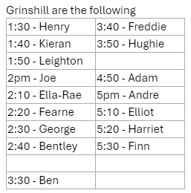
If you would like an appointment and you haven’t made one yet, please contact the office or speak to Mrs Roberts on the gate.

